(K8S) Kubernetes Task -01

- Setup Minikube in your local machine.
- Setup k8s master and two worker nodes on ubuntu.
- Run one nginx pod.
- Mugup Master and slave components on k8s.

Task:1 Setup Minikube in your local windows machine.

Minikube:
========
Minikube is a single cluster with all k8s component.
minikube is used for learning and development purposes.

1) Install Docker on windows.
https://docs.docker.com/desktop/install/windows-install/
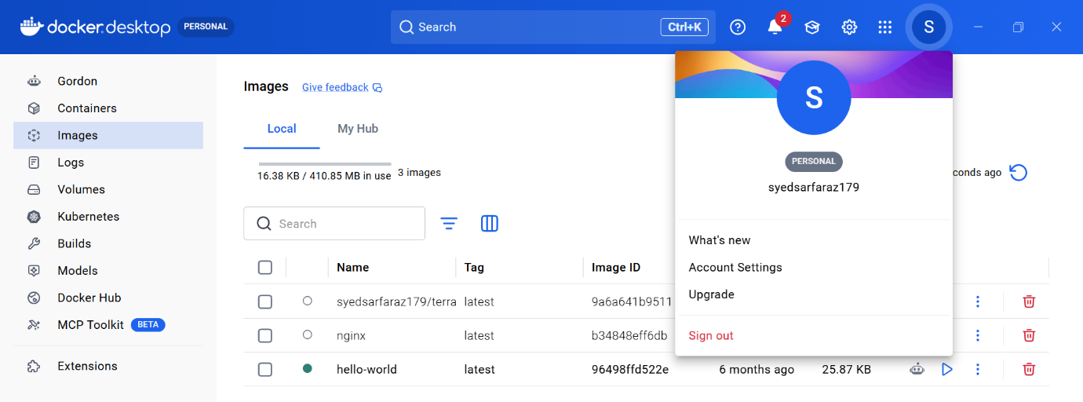
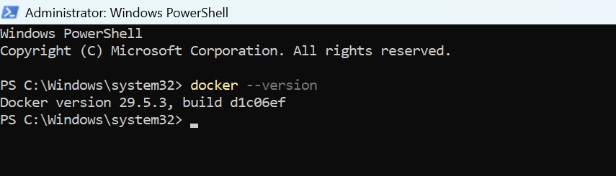
2) Install Oracle box on windows
https://adamtheautomator.com/install-virtualbox-on-windows-10/
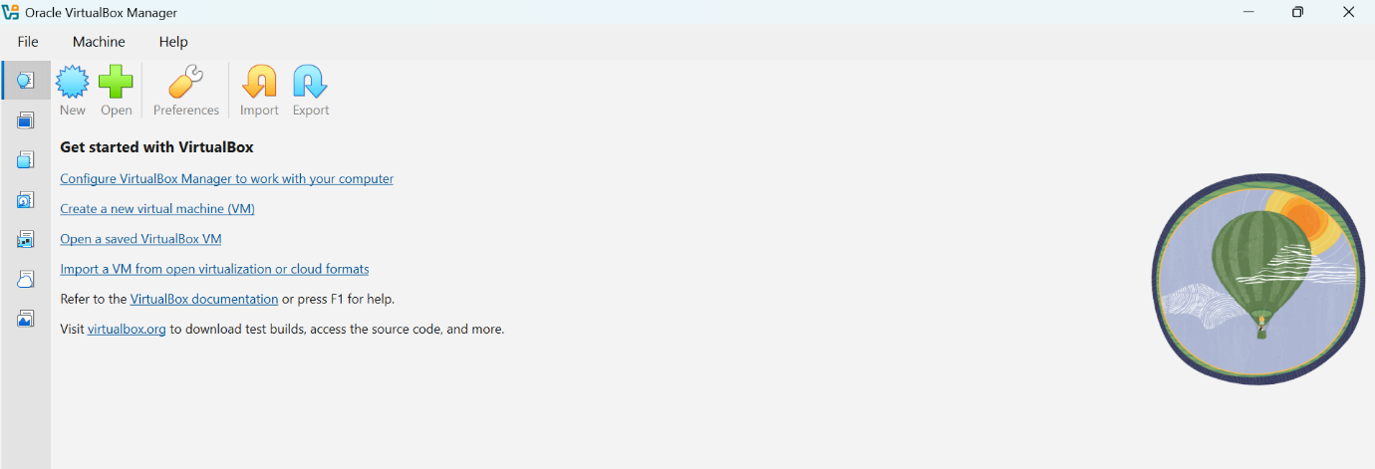

3) Check system info in CMD
systeminfo
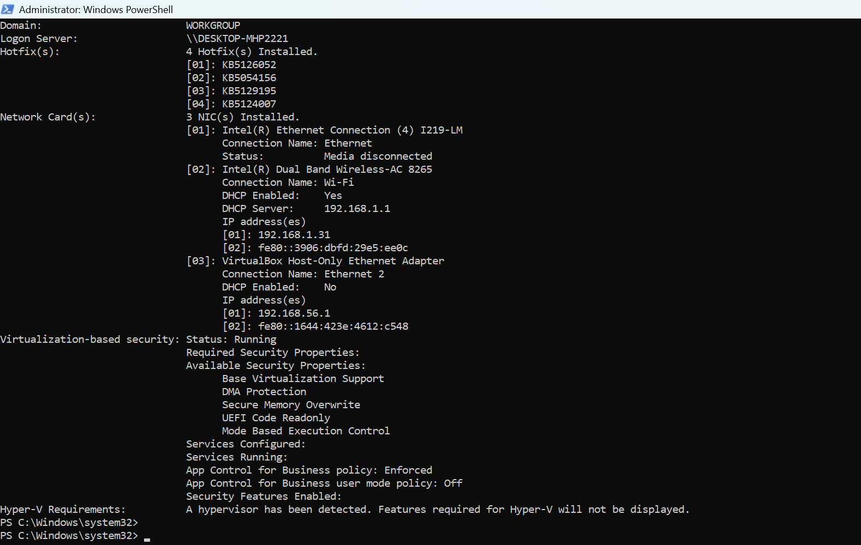

4) Install Minikube using powershell
https://minikube.sigs.k8s.io/docs/start/
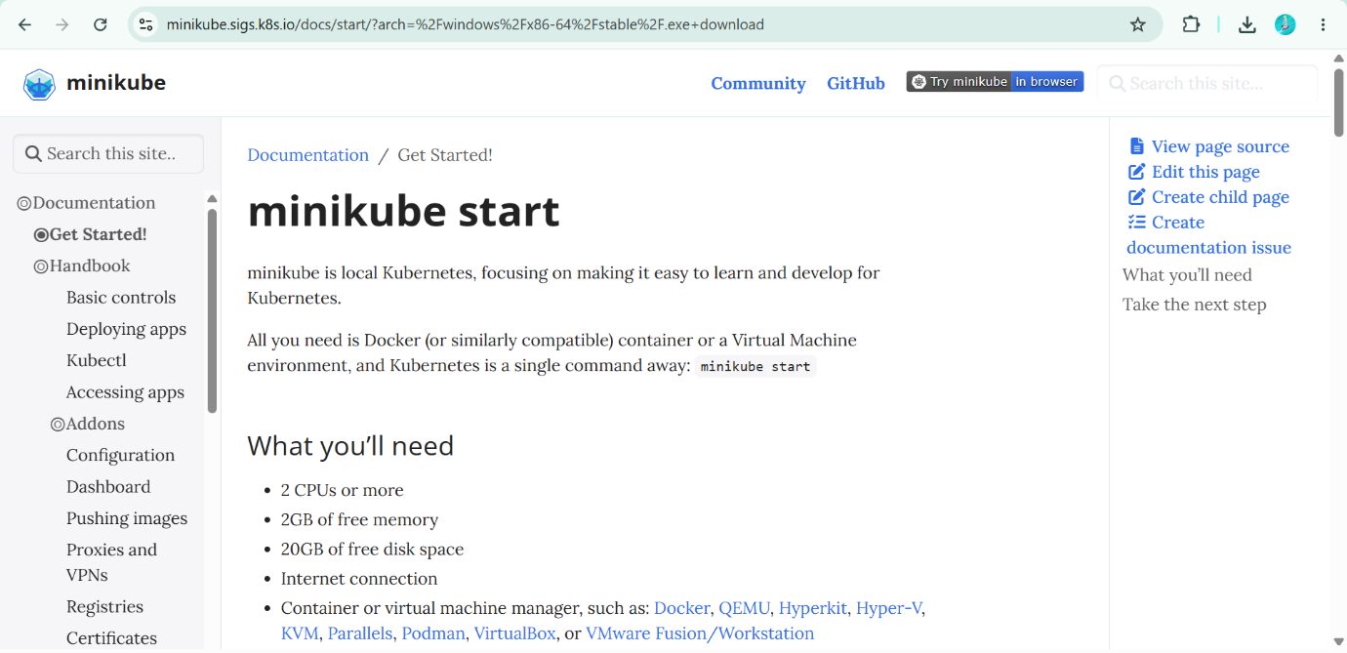
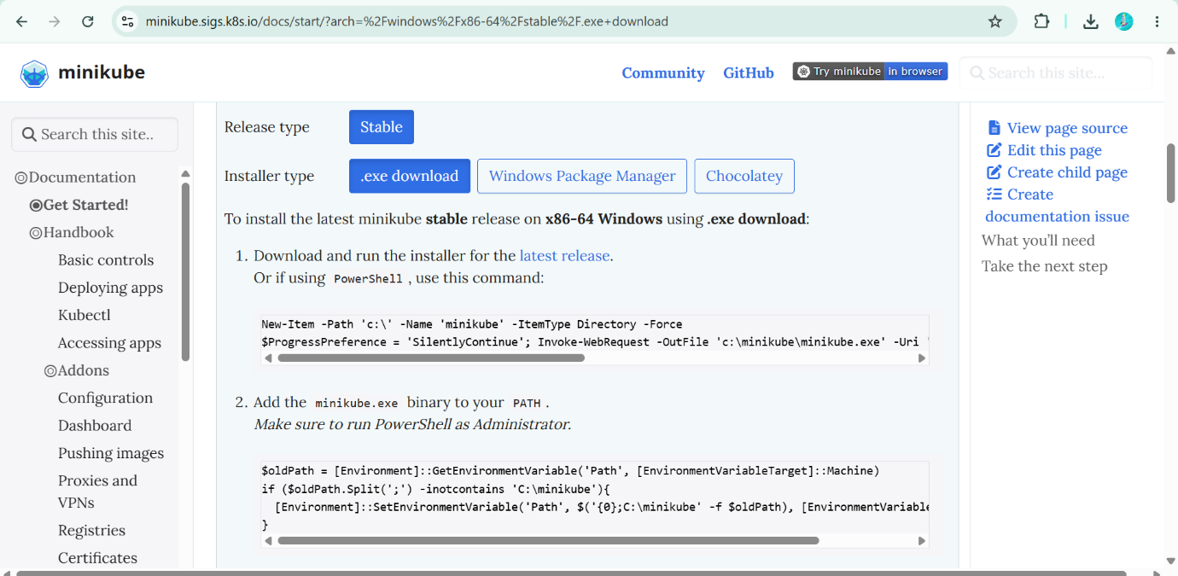
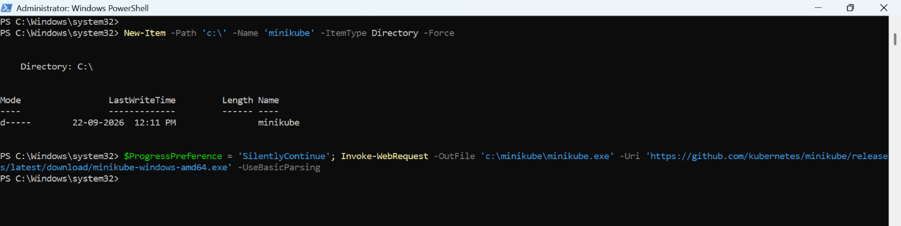

5) Set the minikube path to environmental varaible
export PATH=$PATH:/c/minikube
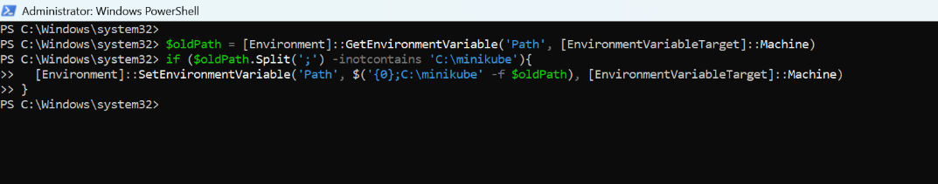
6) Restart powershell and start minikube
$ minikube start
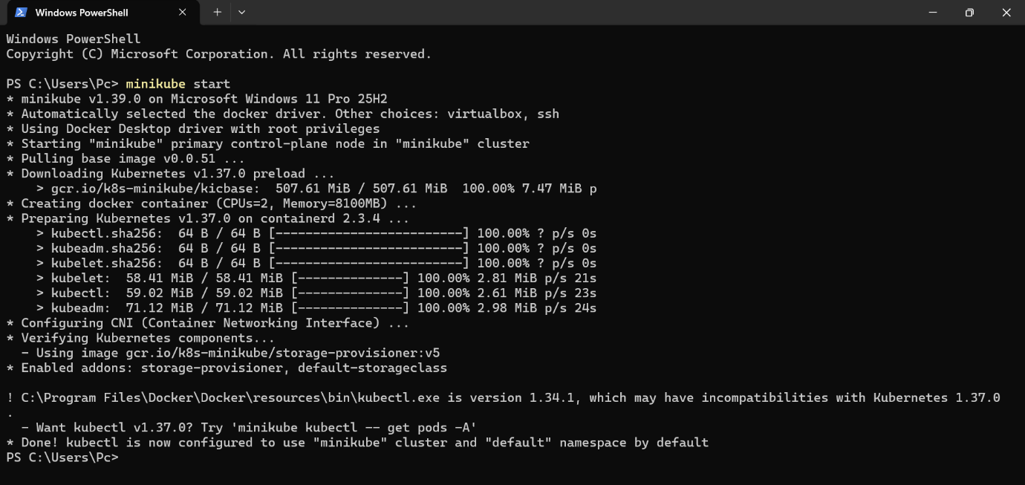
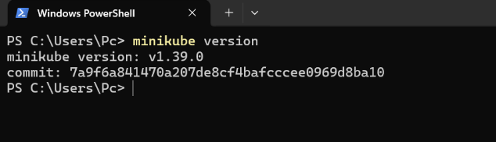

To check minikube ip use : minikube ip
To ssh to minikube: minikube ssh
To connect or check the pods : kubectl get pods

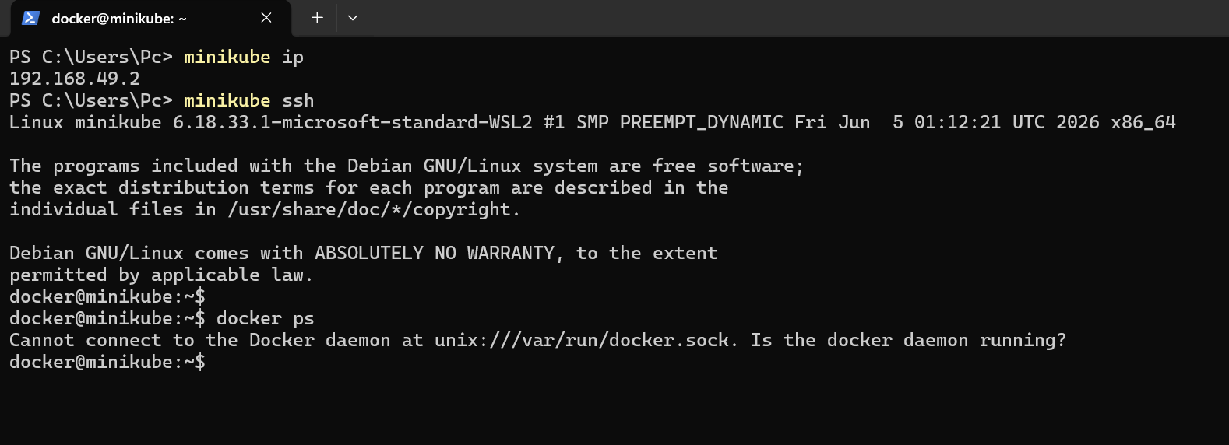

Task: 2 Setup k8s master and two worker nodes on ubuntu.

Sabair Bhai Steps

Setup 3 nodes k8s cluster,1 master and 2 node machines:
======================================================
1) launch 3 instances of type t2.medium and linux2 AMI.

2) Disable swap memory from instances.(Because k8s wants the cpu to utilized 100%)
free - h to check the swap memeory allocated
swapoff -a to off the swap memory
To not enable this after restart then comment this in fstab file.

3) Install docker based on Operating system in 3 instances.
https://docs.docker.com/engine/install/

4) To setup k8s cluster we have different tools like kops and kubeadm.
https://kubernetes.io/docs/setup/production-environment/tools/kubeadm/install-kubeadm/

5) Now we need to setup networking and configure master and worker nodes.
https://kubernetes.io/docs/setup/production-environment/tools/kubeadm/create-cluster-kubeadm/

6) TO configure master we need to initialize with CIDR
kubeadm init --pod-network-cidr=10.244.0.0/16

7) To start using your cluster, you need to run the following as a regular user:
mkdir -p $HOME/.kube
sudo cp -i /etc/kubernetes/admin.conf $HOME/.kube/config
sudo chown $(id -u):$(id -g) $HOME/.kube/config

8) If we execute kubectl get nodes we can see the status as notready because we haven't installed flannel

9) Install Flannel and check the status of nodes
kubectl apply -f https://github.com/flannel-io/flannel/releases/latest/download/kube-flannel.yml

10) Now copy the token and execute on worker machines.

Chat-Gpt Steps

Step 1: Create 3 Ubuntu Nodes
Create 3 Ubuntu EC2 instances:

Node | Role
k8s-master | Master
k8s-worker1 | Worker
k8s-worker2 | Worker
Use the Ubuntu AMI you specified:
ami-0b6d9d3d33ba97d99
Make sure all 3 machines can communicate with each other using their private IP addresses.
You will need:
MASTER_PRIVATE_IP
WORKER1_PRIVATE_IP
WORKER2_PRIVATE_IP
Allow the required Kubernetes communication between the three nodes in your AWS Security Group.

Step 2: Remove Old Docker Versions
Run this command on all 3 nodes:
$ sudo apt remove $(dpkg --get-selections docker.io docker-compose docker-compose-v2 docker-doc docker-buildx podman-docker containerd runc | cut -f1)
If some packages are not installed, that is okay.

Step 3: Install Docker
Run the following on all 3 nodes.
3.1 Update packages
sudo apt update
3.2 Install required packages
sudo apt install -y ca-certificates curl
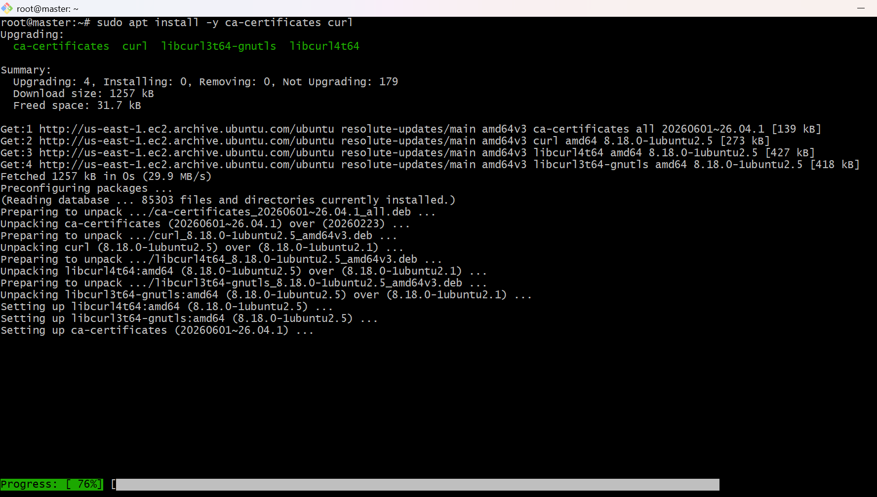
3.3 Add Docker GPG key
sudo install -m 0755 -d /etc/apt/keyrings
sudo curl -fsSL https://download.docker.com/linux/ubuntu/gpg \
-o /etc/apt/keyrings/docker.asc
sudo chmod a+r /etc/apt/keyrings/docker.asc
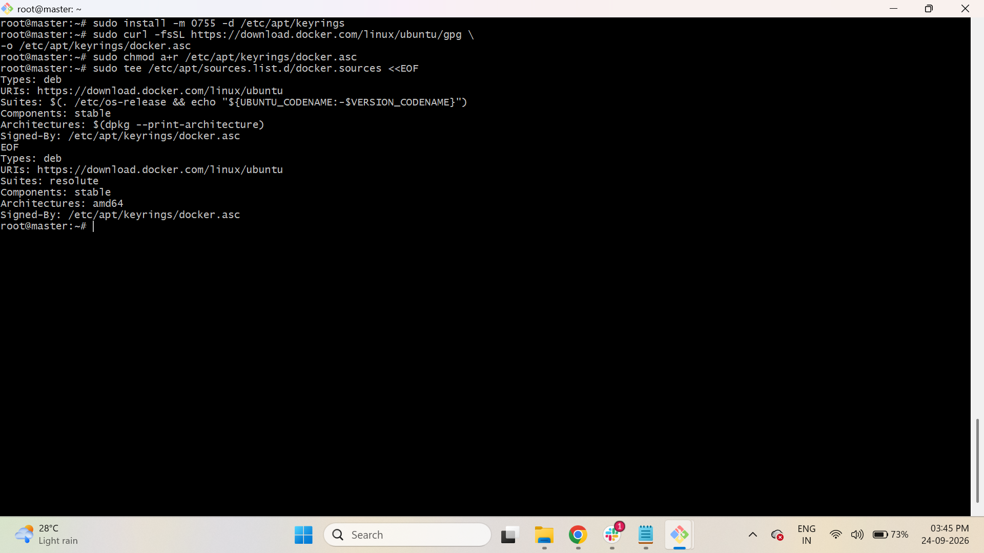
3.4 Add Docker repository
sudo tee /etc/apt/sources.list.d/docker.sources <<EOF
Types: deb
URIs: https://download.docker.com/linux/ubuntu
Suites: $(. /etc/os-release && echo "${UBUNTU_CODENAME:-$VERSION_CODENAME}")
Components: stable
Architectures: $(dpkg --print-architecture)
Signed-By: /etc/apt/keyrings/docker.asc
EOF
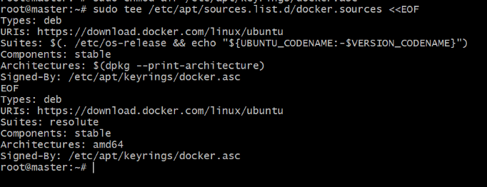
3.5 Update repository
sudo apt update
3.6 Install Docker and containerd
sudo apt install -y docker-ce docker-ce-cli containerd.io docker-buildx-plugin docker-compose-plugin
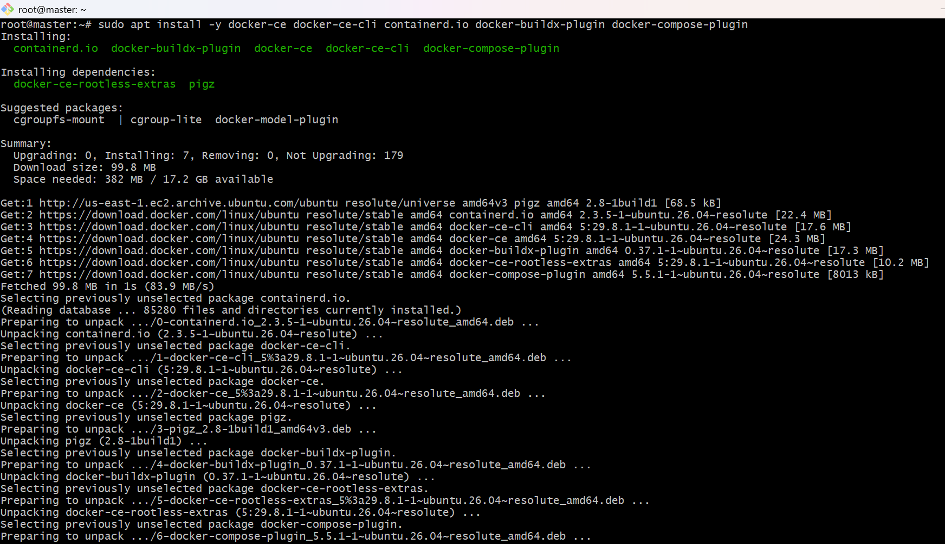
3.7 Start Docker
sudo systemctl start docker
sudo systemctl enable docker
Verify:
sudo systemctl status docker
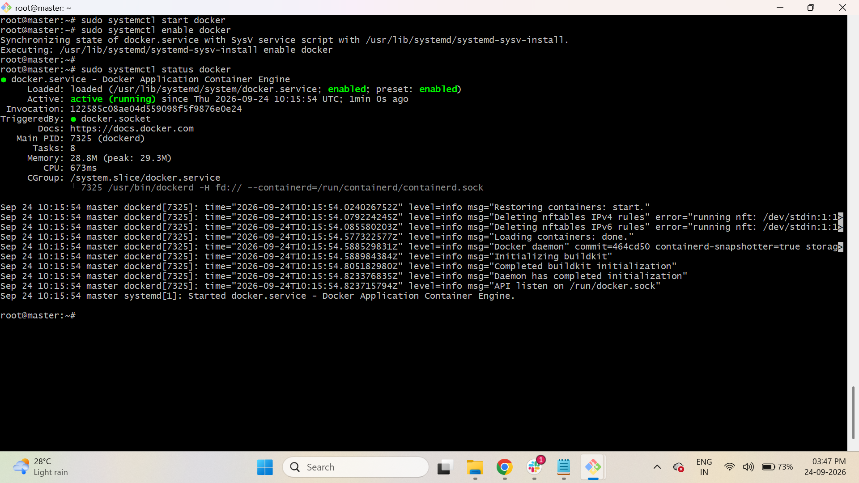

Step 4: Disable Swap
Run on all 3 nodes:
sudo swapoff -as
To verify:
free -h
Swap should show 0.
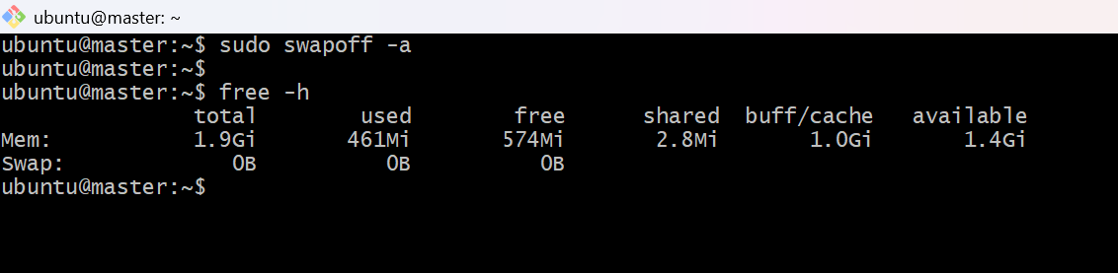

Step 5: Configure Kubernetes Network
Run on all 3 nodes.
5.1 Load required kernel modules
cat <<EOF | sudo tee /etc/modules-load.d/k8s.conf
overlay
br_netfilter
EOF
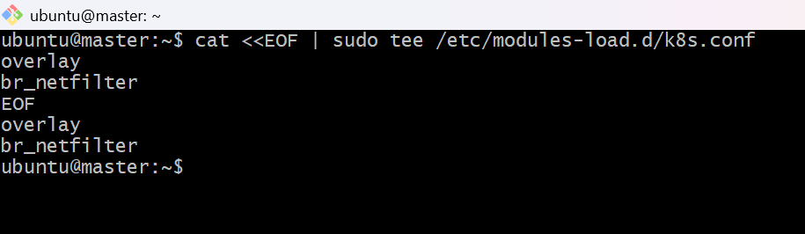
Load the modules:
sudo modprobe overlay
sudo modprobe br_netfilter
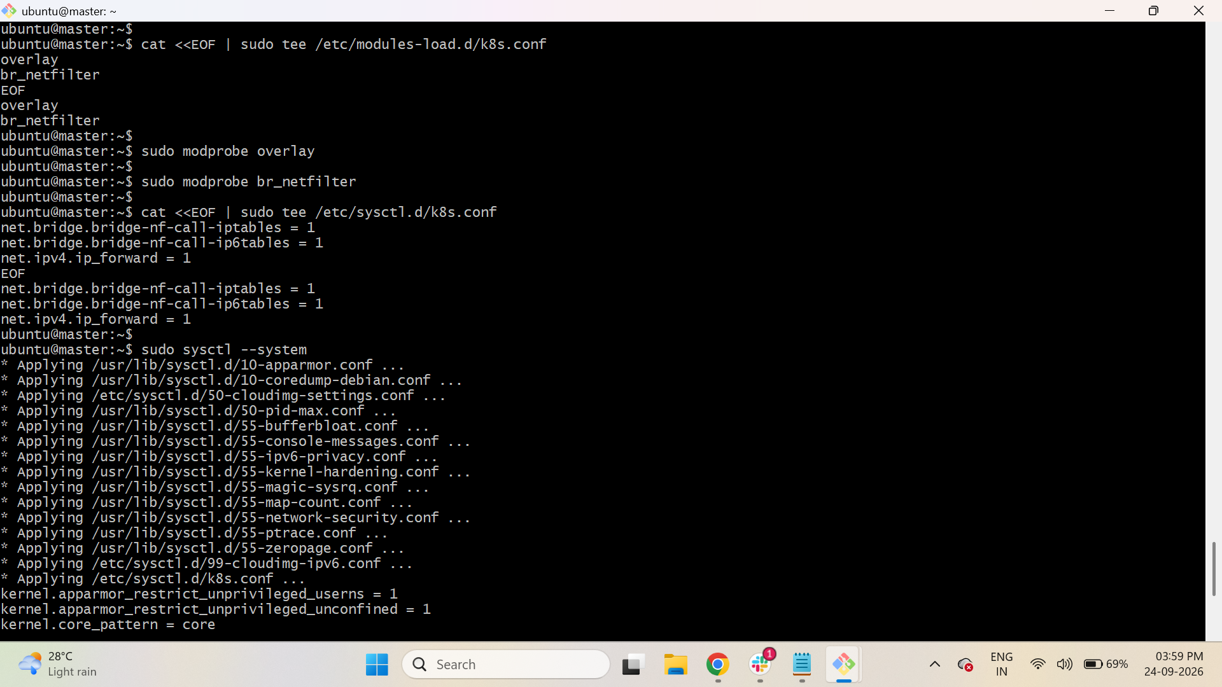
5.2 Configure IPv4 forwarding and bridge networking
cat <<EOF | sudo tee /etc/sysctl.d/k8s.conf
net.bridge.bridge-nf-call-iptables = 1
net.bridge.bridge-nf-call-ip6tables = 1
net.ipv4.ip_forward = 1
EOF
Apply the configuration:
sudo sysctl –system
Verify:
sysctl net.ipv4.ip_forward
It should show:
net.ipv4.ip_forward = 1
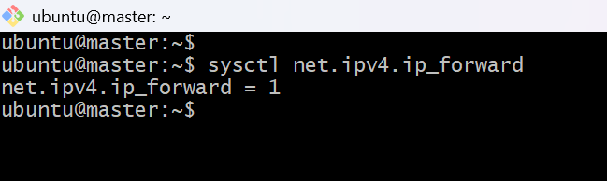

Step 6: Install kubelet, kubeadm and kubectl
Run on all 3 nodes.
6.1 Install required packages
sudo apt-get update
sudo apt-get install -y apt-transport-https ca-certificates curl gpg
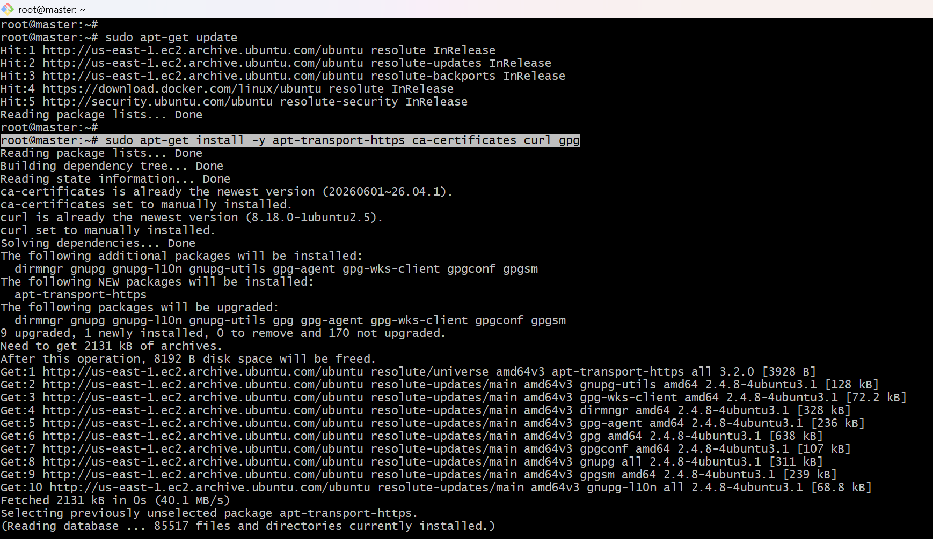
6.2 Add Kubernetes repository key
sudo mkdir -p /etc/apt/keyrings
curl -fsSL https://pkgs.k8s.io/core:/stable:/v1.29/deb/Release.key | \
sudo gpg --dearmor -o /etc/apt/keyrings/kubernetes-apt-keyring.gpg
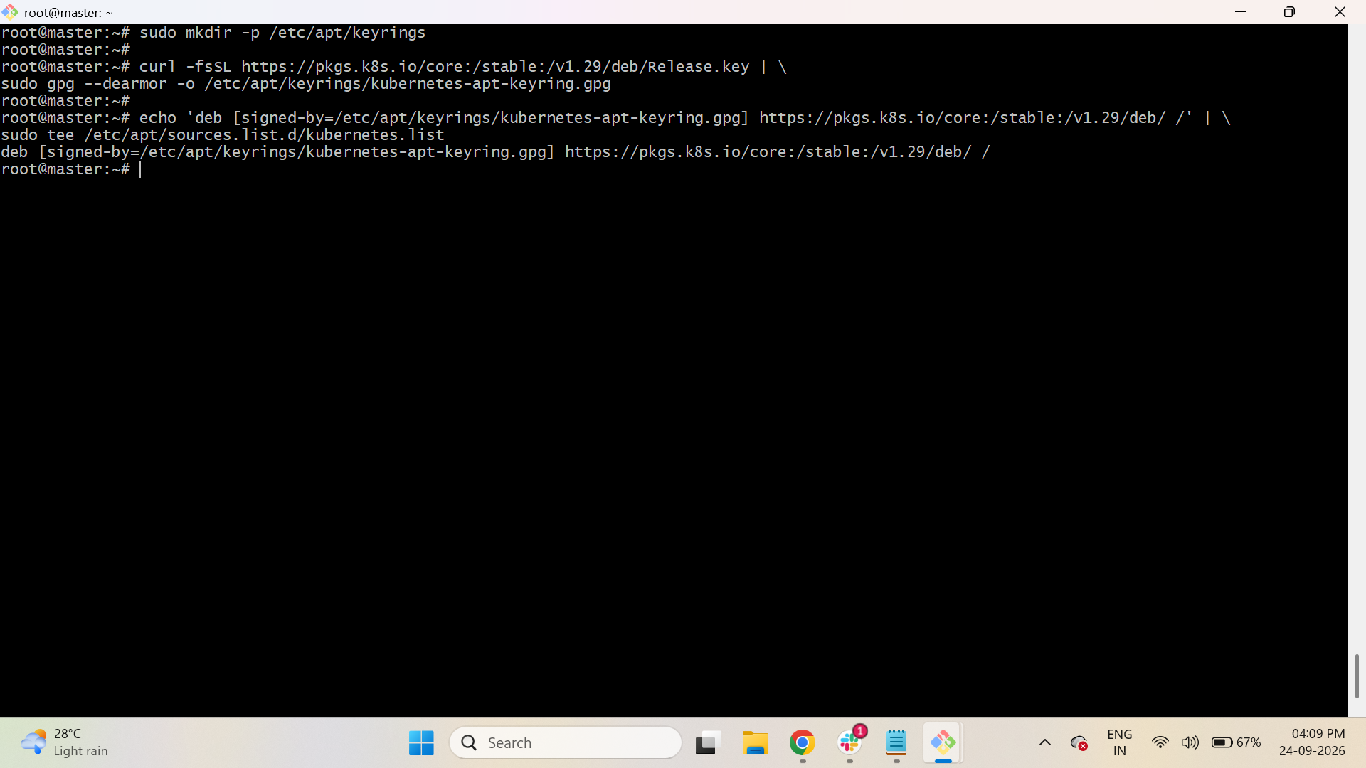
6.3 Add Kubernetes repository
$ echo 'deb [signed-by=/etc/apt/keyrings/kubernetes-apt-keyring.gpg] https://pkgs.k8s.io/core:/stable:/v1.29/deb/ /' | \
$ sudo tee /etc/apt/sources.list.d/kubernetes.list
6.4 Install Kubernetes components
sudo apt-get update
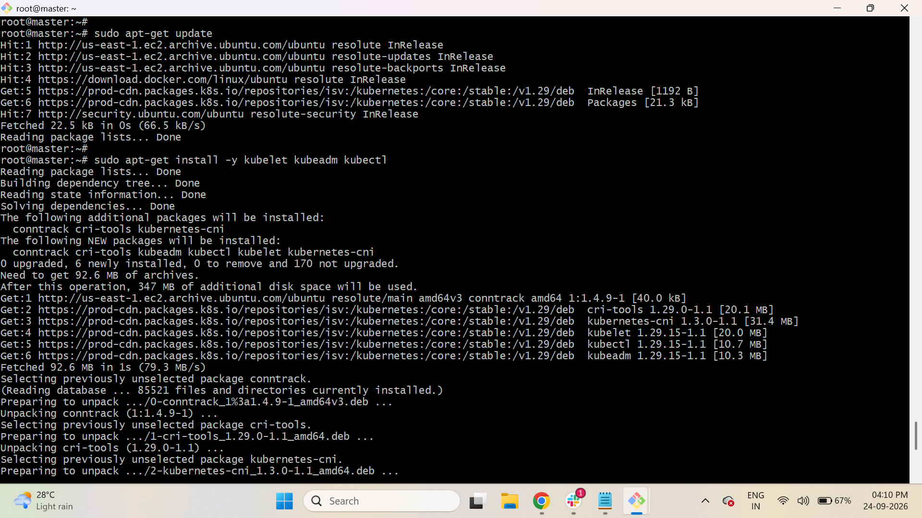
sudo apt-get install -y kubelet kubeadm kubectl
6.5 Hold Kubernetes packages
sudo apt-mark hold kubelet kubeadm kubectl
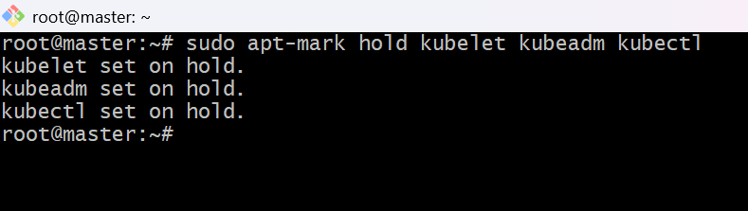

Step 7: Configure containerd
Run on all 3 nodes.
First generate the containerd configuration:
$ sudo mkdir -p /etc/containerd
$ sudo containerd config default | sudo tee /etc/containerd/config.toml
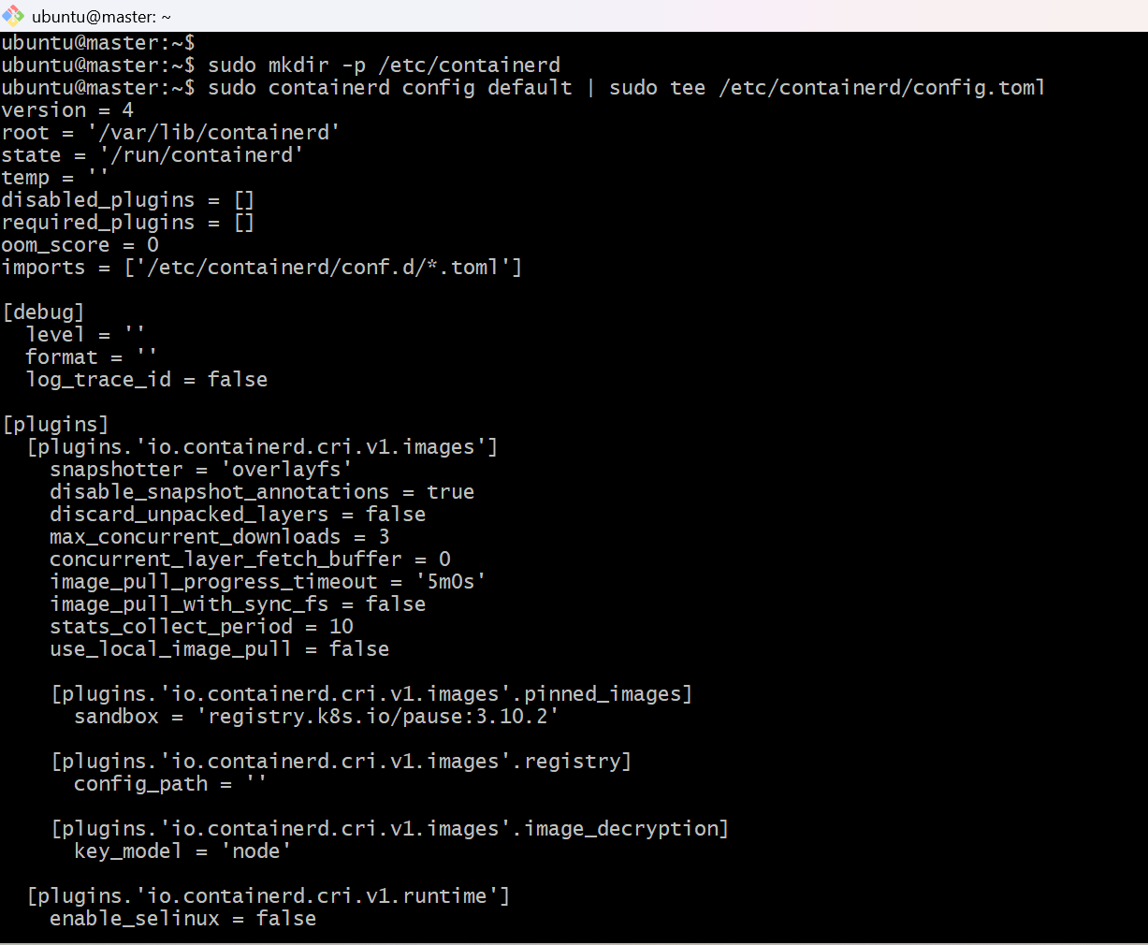

Now enable SystemdCgroup:
sudo sed -i 's/SystemdCgroup = false/SystemdCgroup = true/' /etc/containerd/config.toml
Restart containerd:
sudo systemctl restart containerd
Enable it:
sudo systemctl enable containerd
Restart kubelet:
sudo systemctl restart kubelet
Enable kubelet:
sudo systemctl enable kubelet
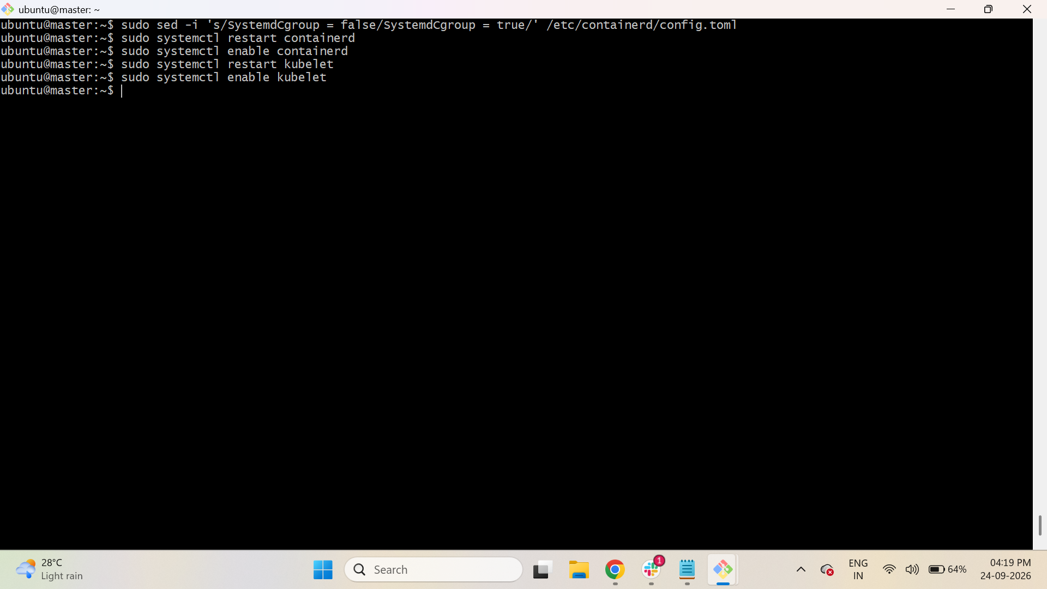

Step 8: Initialize Kubernetes Master
Run these commands ONLY on the MASTER node.
First pull the Kubernetes images:
$ sudo kubeadm config images pull
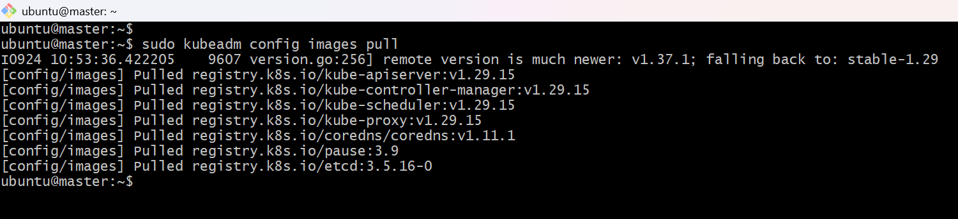
Initialize the cluster:
$ sudo kubeadm init --pod-network-cidr=10.10.0.0/16

This will take some time.
At the end, kubeadm will display a kubeadm join command.

It will look similar to:
kubeadm join 172.31.2.119:6443 --token onx1pa.d3gwwp2jvrv43nqd \
--discovery-token-ca-cert-hash sha256:de0bd406d8e1cdabf959426c3ebdcc919c96343eab0c9fad59b1b81fba5b71a4
Save this command. You will use it on both worker nodes.
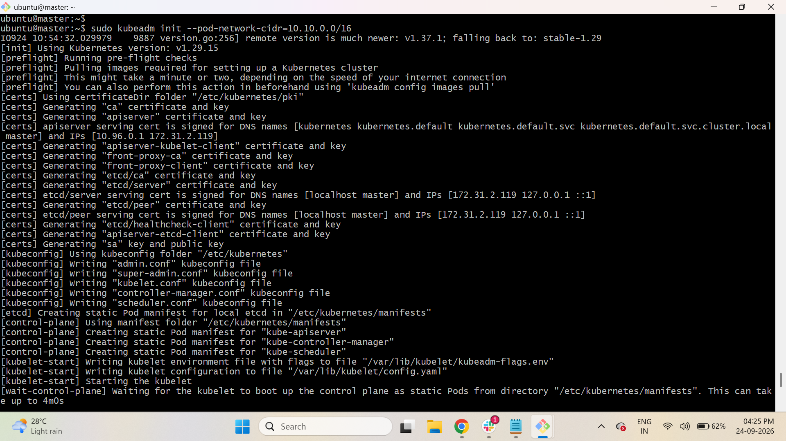
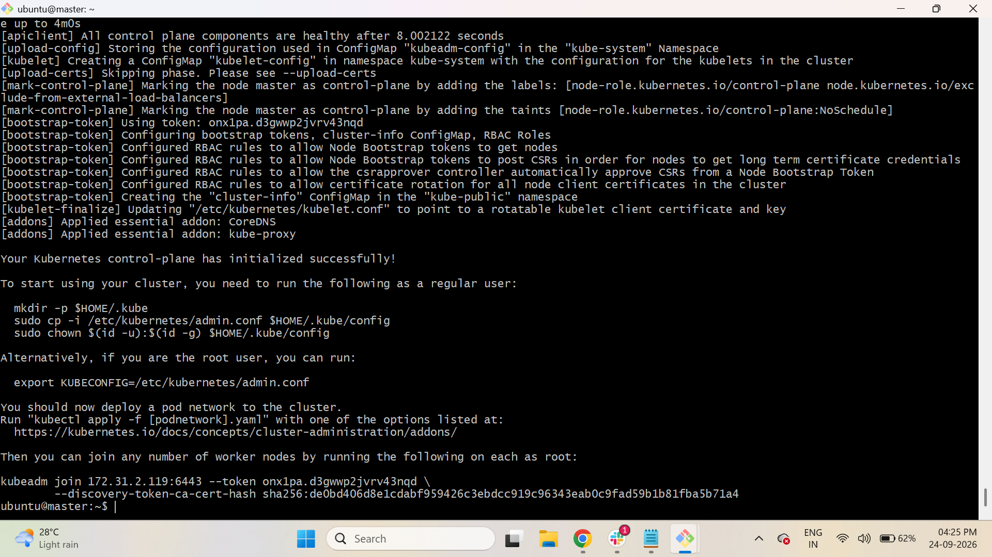

Step 9: Configure kubectl on Master

Still on the MASTER node:
$ mkdir -p $HOME/.kube
$ sudo cp -i /etc/kubernetes/admin.conf $HOME/.kube/config
$ sudo chown $(id -u):$(id -g) $HOME/.kube/config
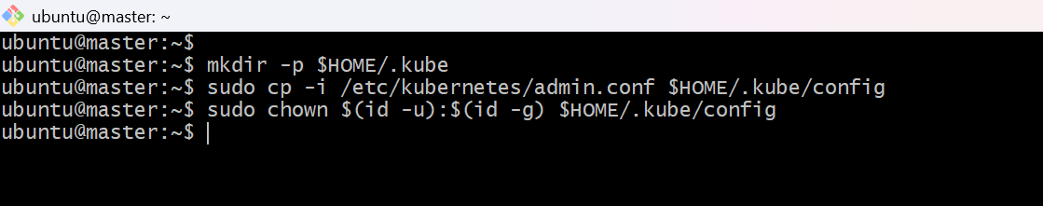

Check:
kubectl get nodes
At this point, the master will normally show:
NAME STATUS ROLES AGE
k8s-master NotReady control-plane ...
NotReady is expected until the pod network is installed.
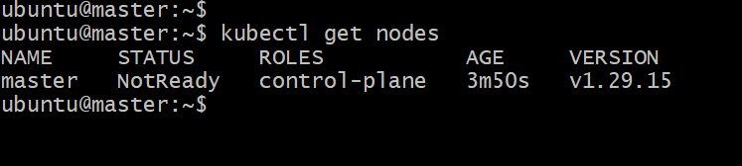

Step 10: Install Calico Network

Run these commands ONLY on the MASTER node.
Install the Calico operator:
$ kubectl create -f https://raw.githubusercontent.com/projectcalico/calico/v3.26.1/manifests/tigera-operator.yaml
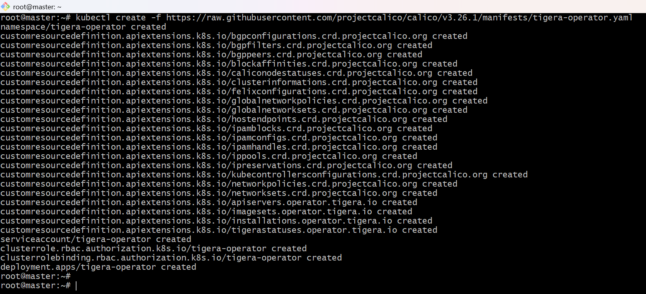

Download Calico configuration:
$ curl https://raw.githubusercontent.com/projectcalico/calico/v3.26.1/manifests/custom-resources.yaml -O
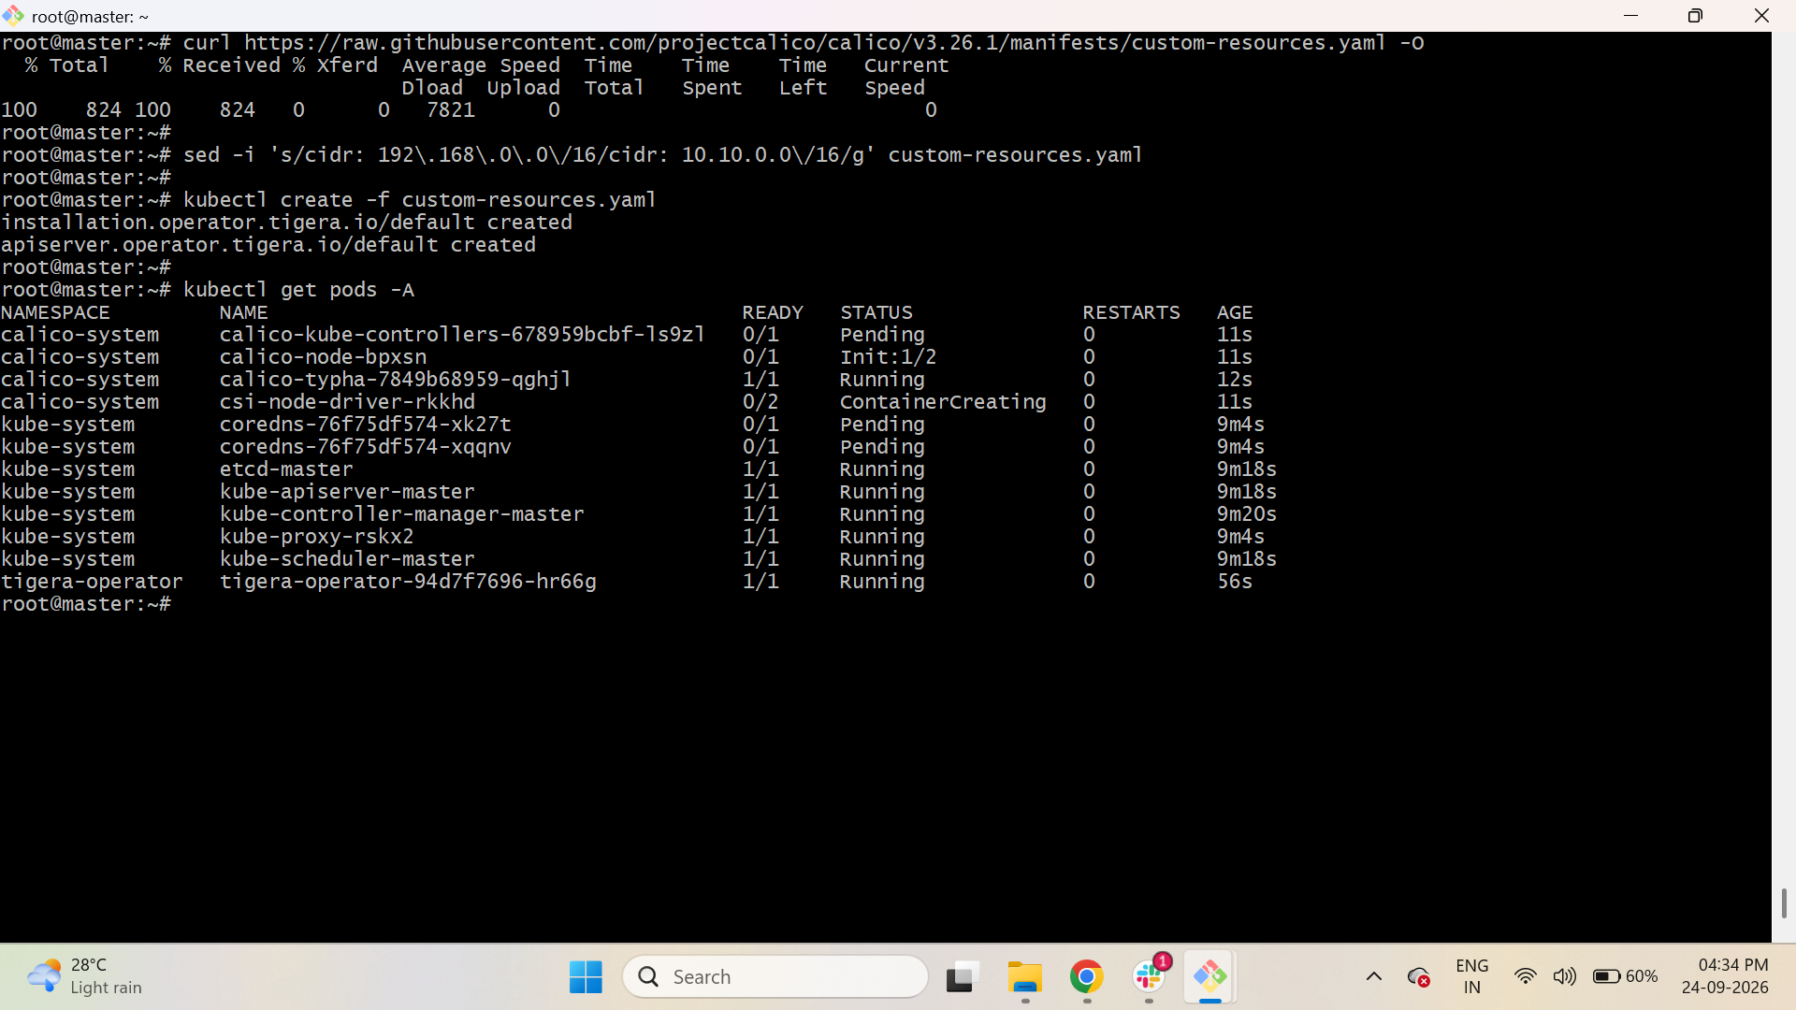

Change the default Calico CIDR to your Kubernetes pod CIDR:
sed -i 's/cidr: 192\.168\.0\.0\/16/cidr: 10.10.0.0\/16/g' custom-resources.yaml
Apply it:
kubectl create -f custom-resources.yaml
Wait for Calico to start:
kubectl get pods -A

Step 11: Join Worker 1
Go to WORKER 1.
Run the kubeadm join command that was displayed during kubeadm init.
Example:
kubeadm join 172.31.2.119:6443 --token onx1pa.d3gwwp2jvrv43nqd \
--discovery-token-ca-cert-hash sha256:de0bd406d8e1cdabf959426c3ebdcc919c96343eab0c9fad59b1b81fba5b71a4
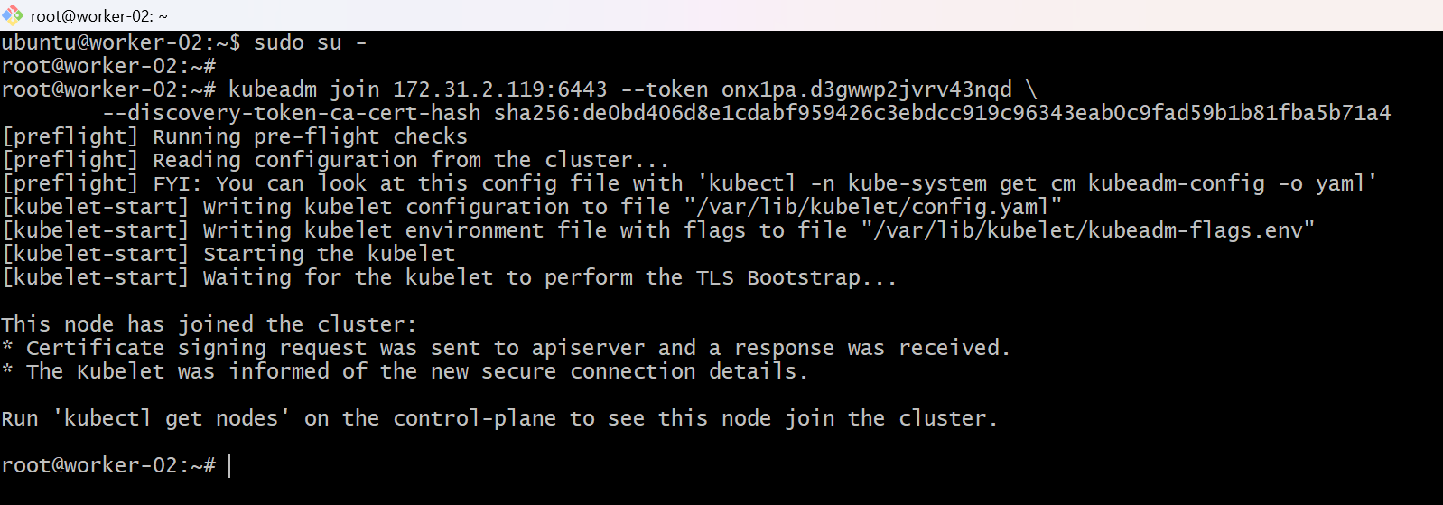

Step 12: Join Worker 2
Go to WORKER 2.
Run the same kubeadm join command:
kubeadm join 172.31.2.119:6443 --token onx1pa.d3gwwp2jvrv43nqd \
--discovery-token-ca-cert-hash sha256:de0bd406d8e1cdabf959426c3ebdcc919c96343eab0c9fad59b1b81fba5b71a4

Step 13: Verify the Cluster
Go back to the MASTER node.
Run:
$ kubectl get nodes
You should see 3 nodes:
NAME STATUS ROLES AGE
k8s-master Ready control-plane ...
k8s-worker1 Ready <none> ...
k8s-worker2 Ready <none> ...
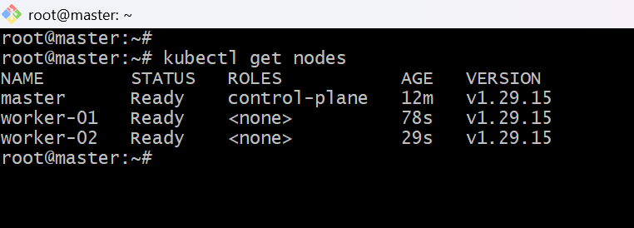
Also verify all Kubernetes system pods:
$ kubectl get pods -A
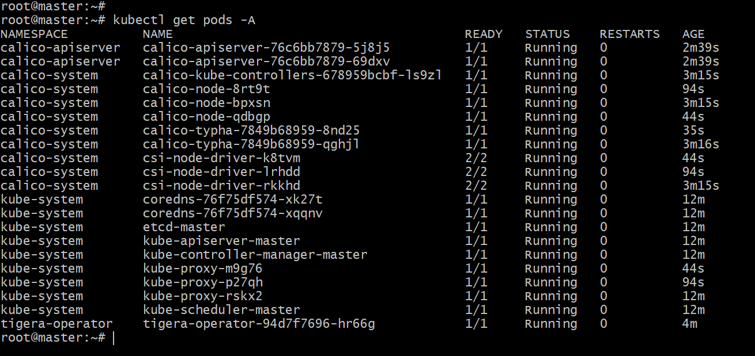
The important part is that the nodes eventually show:
Ready
Your 1 Master + 2 Worker Kubernetes cluster is now set up.

Kubernetes Master–Worker Workflow
Kubernetes Cluster
|
+---------+---------+
| |
MASTER NODE WORKER NODES
(master) / \
| / \
Control Plane worker-01 worker-02
|
+--------+--------+
| | |
API Scheduler Controller
Server Manager
|
etcd
|
Cluster State

Complete Workflow
1. Create 3 Ubuntu machines
↓
2. Prepare all 3 nodes
├── Docker/containerd
├── Disable swap
└── Configure networking
↓
3. Install Kubernetes
├── kubeadm
├── kubelet
└── kubectl
↓
4. Configure containerd
↓
5. MASTER
└── kubeadm init
↓
6. MASTER
└── Configure kubectl
↓
7. MASTER
└── Install Calico
↓
8. WORKER-01
└── kubeadm join
↓
9. WORKER-02
└── kubeadm join
↓
10. MASTER
├── kubectl get nodes
└── kubectl get pods -A
↓
CLUSTER READY ✅

Task 4: Run one Nginx Pod

Step 1 — Check the cluster
Run on Master:
$ kubectl get nodes
You should see:
NAME STATUS ROLES AGE
master Ready control-plane ...
worker1 Ready <none> ...
worker2 Ready <none> ...
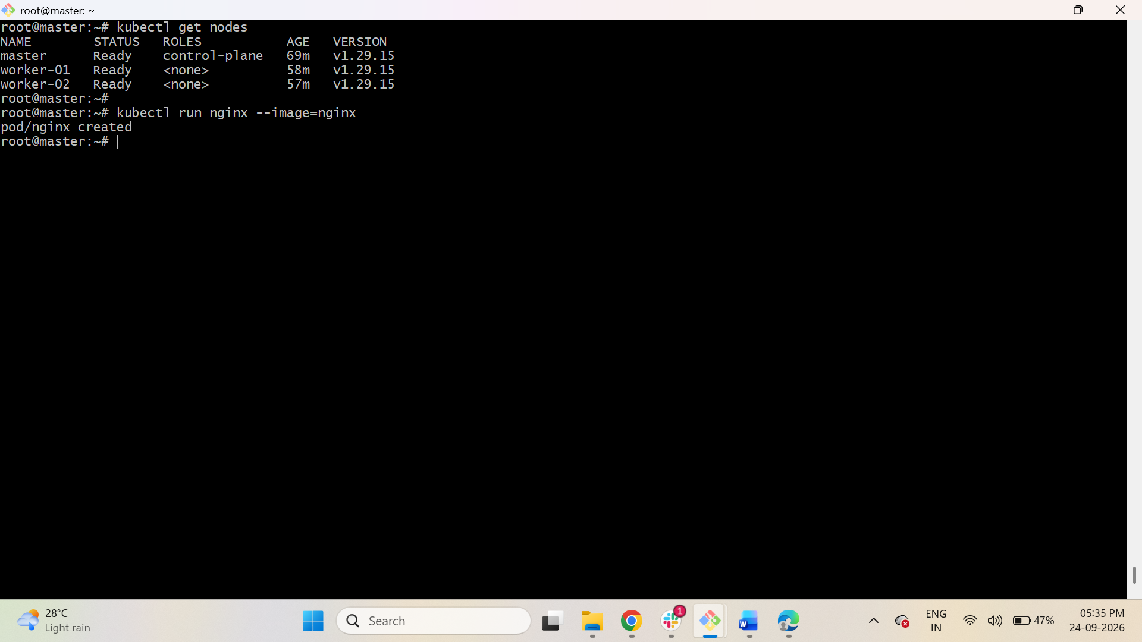

Step 2 — Create an Nginx Pod
Run on Master only:
$ kubectl run nginx --image=nginx
This command tells the Kubernetes master/control-plane to create an Nginx Pod.
You do not manually create the Pod on a worker.

Step 3 — Check the Pod
Run on Master:
$ kubectl get pods -o wide
Example:
NAME READY STATUS RESTARTS AGE IP NODE
nginx 1/1 Running 0 10s 10.244.x.x worker1
The Pod should normally be scheduled on worker1 or worker2.
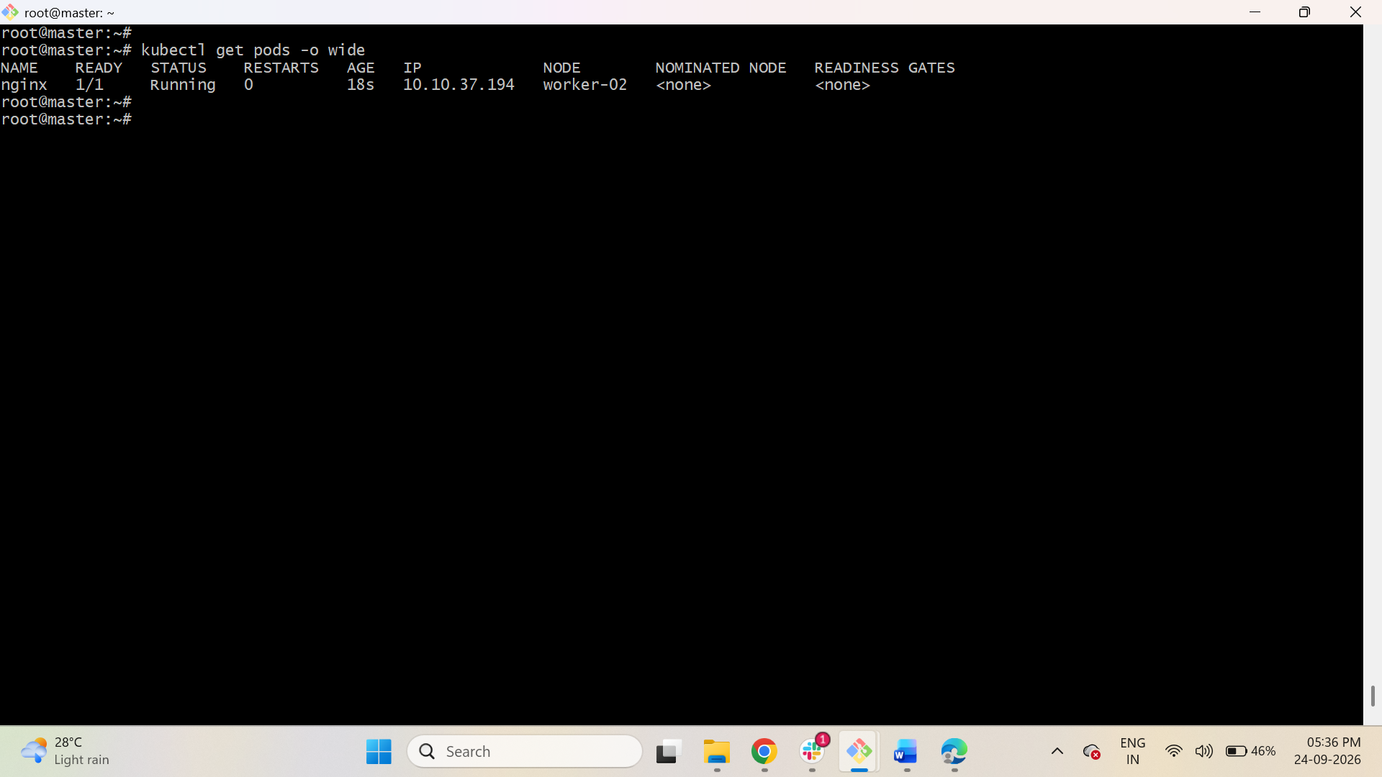

Step 4 — Check Nginx
Run on Master:
$ kubectl describe pod nginx
You can see which worker is running the Pod.
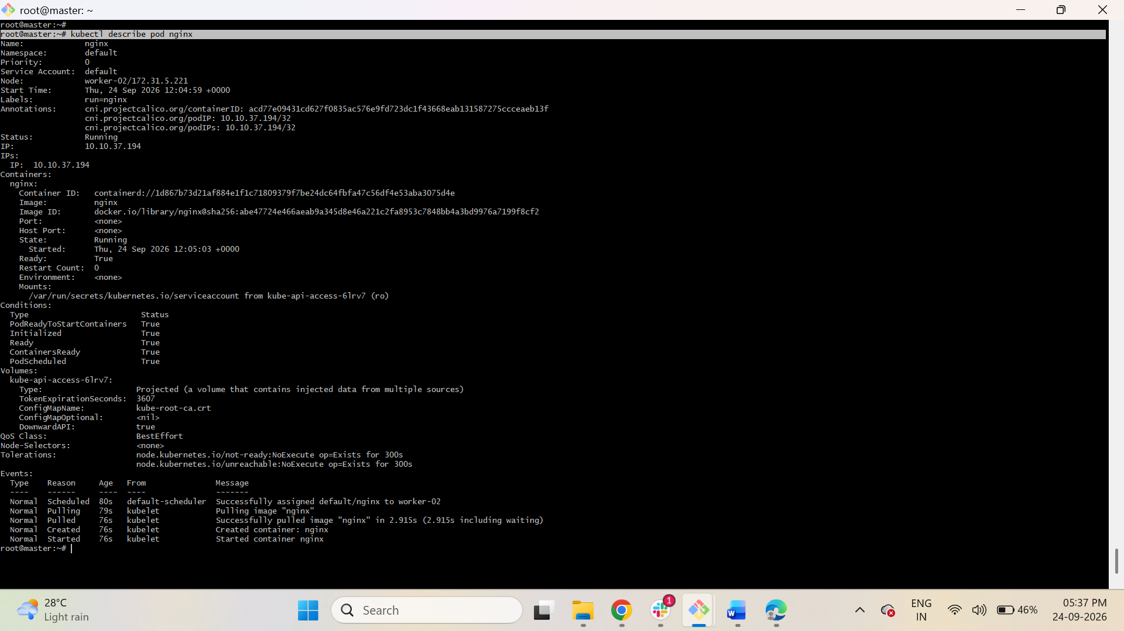
To test Nginx:
kubectl exec -it nginx -- nginx -v
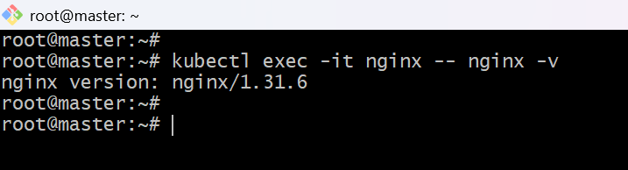
Or:
kubectl exec -it nginx -- curl localhost
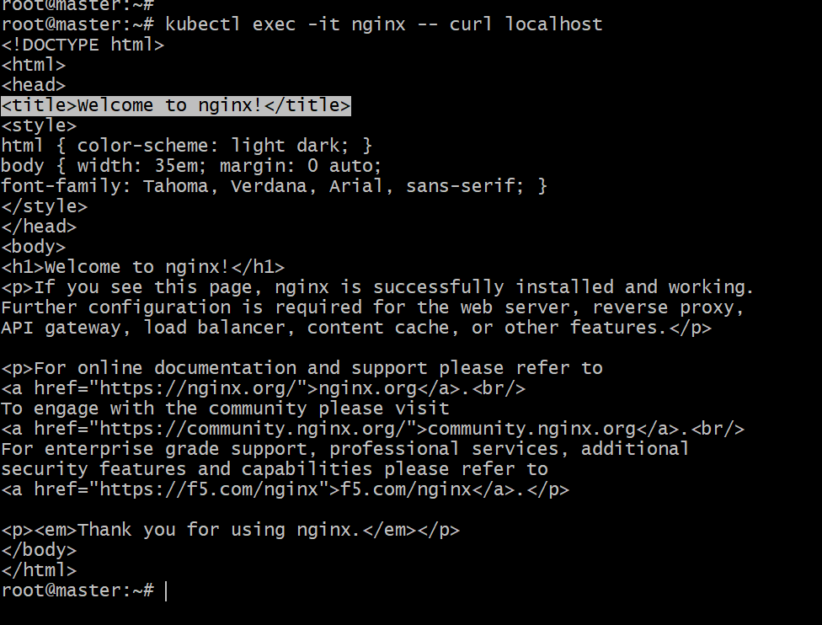

Task 5: Mugup Master and Slave Components on Kubernetes

I assume "Mugup" means "mug up / learn and understand" the Kubernetes master/control-plane and worker-node components.
You don't need to install anything new here. Your existing cluster is used for this task.
A. Master / Control Plane Components
Where?
Master node
Check the components:
kubectl get pods -n kube-system
You should see components such as:
etcd
kube-apiserver
kube-controller-manager
kube-scheduler
1. kube-apiserver
Location: Master
It is the main entry point to Kubernetes.
For example, when you run:
kubectl get pods
kubectl communicates with the kube-apiserver.

2. etcd
Location: Master
Stores the Kubernetes cluster information/state.
For example:
- Nodes
- Pods
- Deployments
- Services
- Configurations
Think:
etcd = Kubernetes database

3. kube-scheduler
Location: Master
Decides which worker node should run a Pod.
Example:
Master
|
| scheduler
↓
Worker 1 → nginx Pod

4. kube-controller-manager
Location: Master
Makes sure the cluster is in the desired state.
For example, if you request:
1 nginx Pod
and the Pod crashes, Kubernetes controllers work to make sure the desired state is restored.

B. Worker / Slave Components
Kubernetes normally uses the term worker node rather than "slave".
Where?
Worker 1 and Worker 2
Check from the Master:
kubectl get nodes

1. kubelet
Location: Every worker node
Responsible for managing Pods on that worker.
For example:
Master
|
| Pod instruction
↓
Worker 1
|
└── kubelet
|
└── nginx Pod
Check on Worker 1 / Worker 2:
systemctl status kubelet

2. Container Runtime
Location: Every worker node
This actually runs the containers.
For your Kubernetes setup, check which runtime you have:
systemctl status containerd
If using containerd, it runs the Nginx container inside the Pod.

3. kube-proxy
Location: Every worker node
Handles Kubernetes networking and helps Pods communicate through Services.
Check:
kubectl get pods -n kube-system -o wide
You should see a kube-proxy Pod running on each worker.

Your Complete Workflow
MASTER / CONTROL PLANE
┌─────────────────────────┐
│ kube-apiserver │
│ etcd │
│ kube-scheduler │
│ kube-controller-manager │
└────────────┬────────────┘
│
kubectl command
│
┌────────────┴────────────┐
↓ ↓
WORKER NODE 1 WORKER NODE 2
┌───────────────┐ ┌───────────────┐
│ kubelet │ │ kubelet │
│ kube-proxy │ │ kube-proxy │
│ containerd │ │ containerd │
│ │ │ │ │
│ nginx Pod │ │ │
└───────────────┘ └───────────────┘
Commands you actually need to perform
MASTER
kubectl get nodes
kubectl run nginx --image=nginx
kubectl get pods -o wide
kubectl describe pod nginx
kubectl get pods -n kube-system
WORKER 1
systemctl status kubelet
systemctl status containerd
WORKER 2
systemctl status kubelet
systemctl status containerd

